

BOAT NAME
CREW LIST



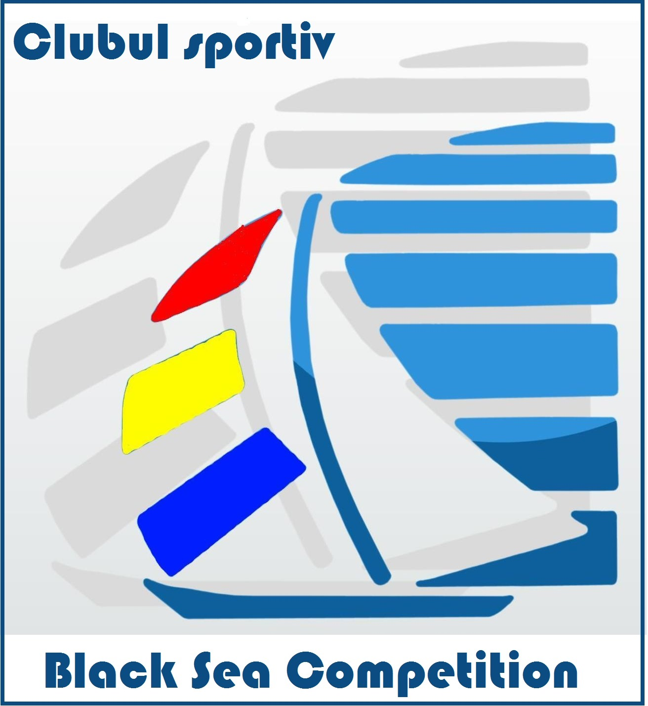
Marina Eforie - Balchik0
29th of August – 01st of September 2019
By signing this form , all crew members takes their own risks and responsibility for the competition period.

No | Position  on board | Name & Surname | Date of Birth | ID doc | Nationality | Postal Address | Email address | Weight  (kg)
 |  | 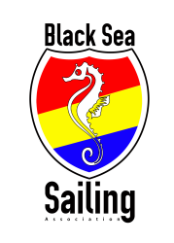
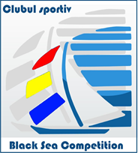
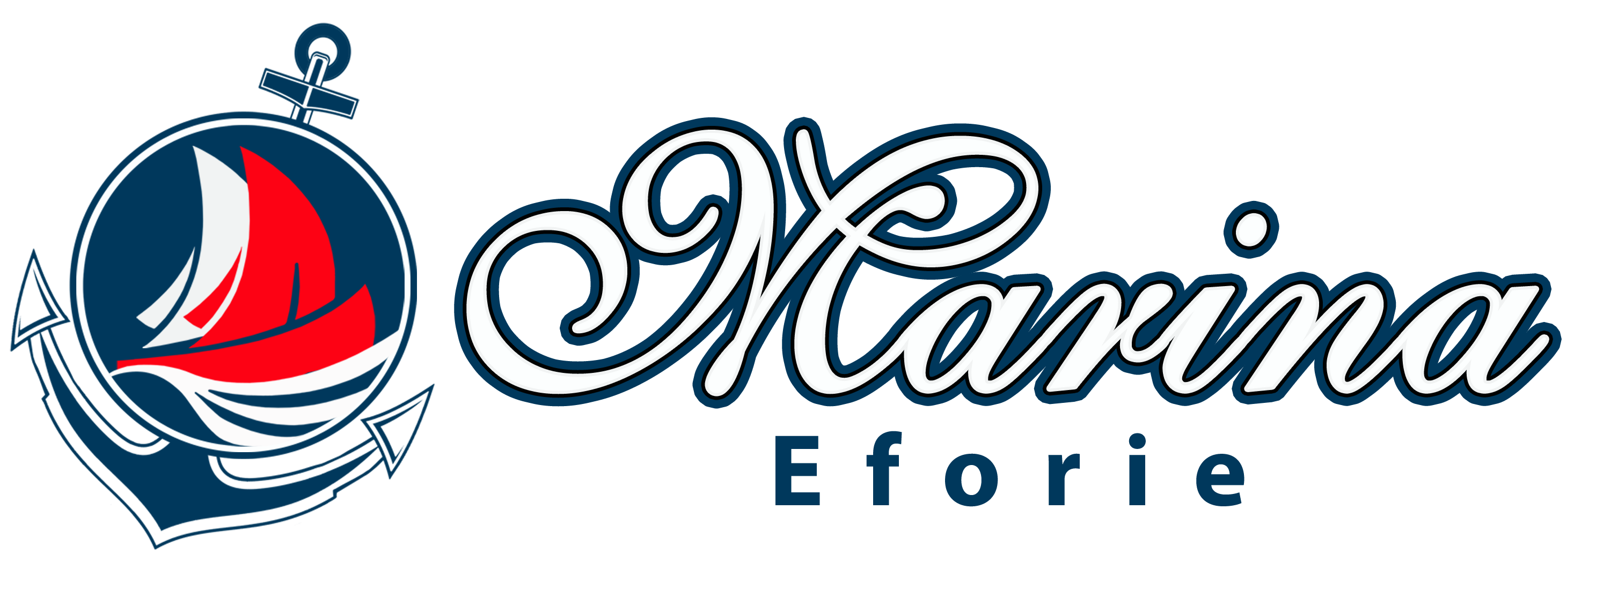

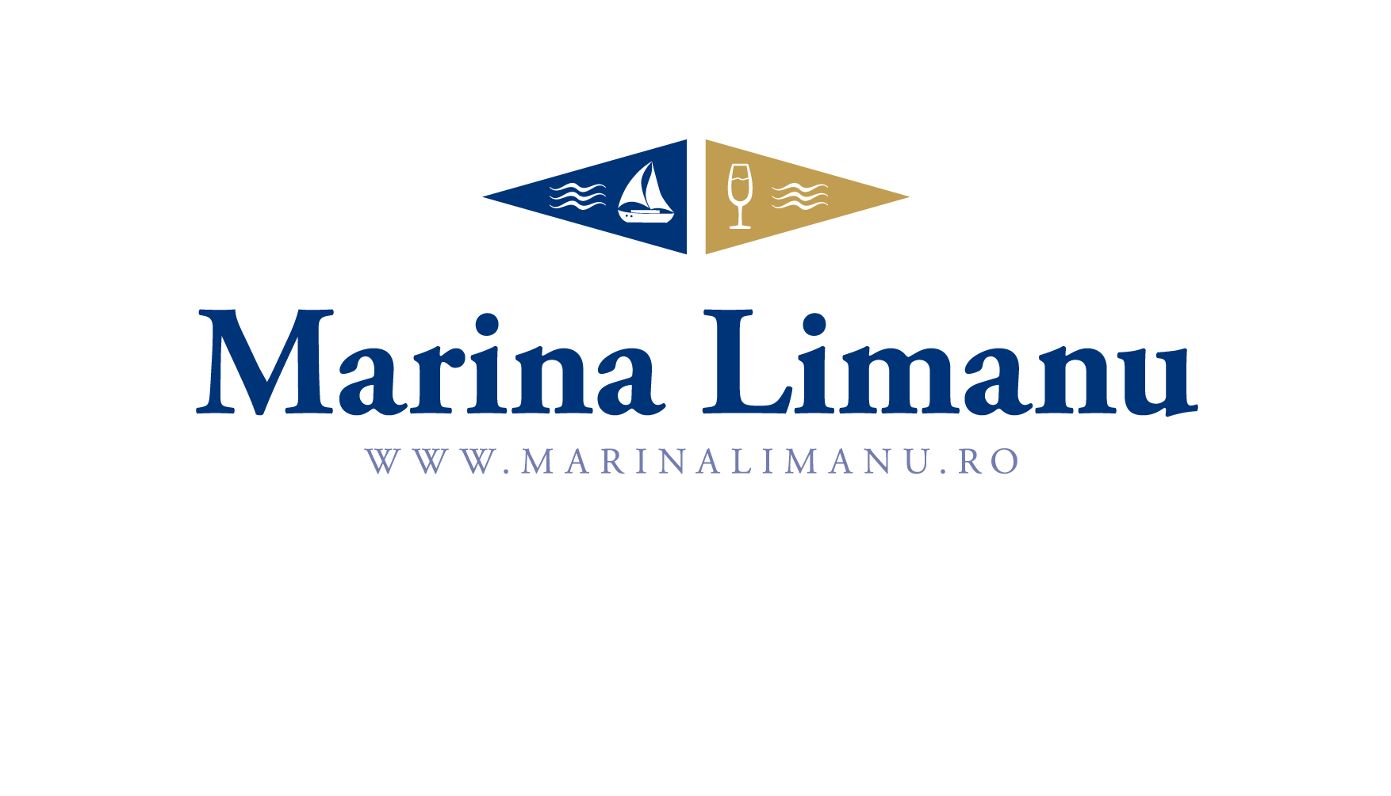
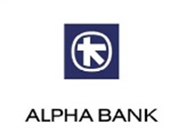
Owner’s / Skipper’s signature ___________________

