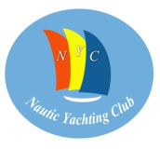

REGATTA 26-28 July 2019
ENTRY FORM
Boat’s name: |  | Sail no.
Country:
Model/Design:
Year Built:
Length overall (m): |  | GPH:
Boats’s rating system: ORC
Owner’s details:
Name:
Address:
E-mail:
Mobile phone no:
Skipper’s details (if different from Owner’s details):
Name:
Address:
E-mail:
Mobile phone no:

Please attach the: ORC Certificate 2019 and Crew List
Please provide the other requested entry documents upon registration

Owner’s / Skipper’s signature ___________________

