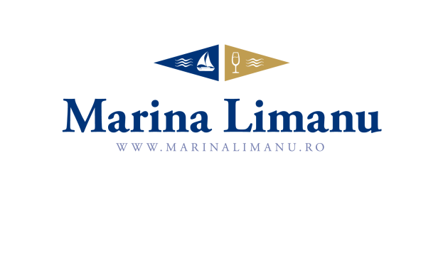

Marina Limanu  REGATTA
5 – 7th of July 2019

DISCLAIMER

The undersigned ..............................................................., nationality ....................................., date of birth ........................, place of birth ........................, female male, resident of Country....................................., City ....................................., str. …………………………………………. ................................................., no. ........., holder of ID doc series ......., no ..........................., issued by ........................................., on the date ........................., personal identification number ...................................................., knowing the provisions of the Criminal Code
- I am the owner/ owner’s representative for the boat ............................................. and I can take the decision to participate along with the crew declared by “Crew List” in the Ziarul Financiar Regatta 2019, organized by Marina Limanu and Nautic Yachting Club Association.
- I learned and I undertake to respect the provisions of C.O.L.R.E.G., I.S.A.F.
- I read the Ziarul Financiar Regatta 2019 Sailing Instructions and I totally agree with them.
- Knowing that the Ziarul Financiar Regatta 2019 takes place in areas where healthcare is not available and participate in the regatta carries risks that can cause loss or destruction of property, as well as injuries and loss of life, said that in case of any event neither I nor any of the crew members I represent will not go in any way against the organizers, sponsors or people involved in organizing the regatta Ziarul Financiar 2019, and exonerating them from liability.
- If, due to my fault or the crew I represent, one of the above mentioned events occurs, I undertake to bear all the consequences, including the payment of the value of the damages caused to the assets of the third parties concerned.
- I read and understood all the above.

Date: ....................... Signature: ........................

