

|  |  |
| --- | --- |
| **BOAT NAME** |  |

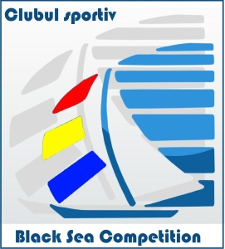

**CREW LIST**



Marina Eforie

14th – 16th of June 2019

|  |  |  |  |  |  |  |  |  |
| --- | --- | --- | --- | --- | --- | --- | --- | --- |
| No | Position  on board | Name & Surname | Date of Birth | ID doc | Nationality | Postal Address | Email address | Weight  (kg) |
|  |  |  |  |  |  |  |  |  |
|  |  |  |  |  |  |  |  |  |
|  |  |  |  |  |  |  |  |  |
|  |  |  |  |  |  |  |  |  |
|  |  |  |  |  |  |  |  |  |
|  |  |  |  |  |  |  |  |  |
|  |  |  |  |  |  |  |  |  |
|  |  |  |  |  |  |  |  |  |
|  |  |  |  |  |  |  |  |  |
|  |  |  |  |  |  |  |  |  |
|  |  |  |  |  |  |  |  |  |
|  |  |  |  |  |  |  |  |  |

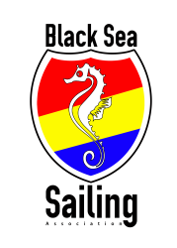***Owner’s / Skipper’s signature ___________________***

